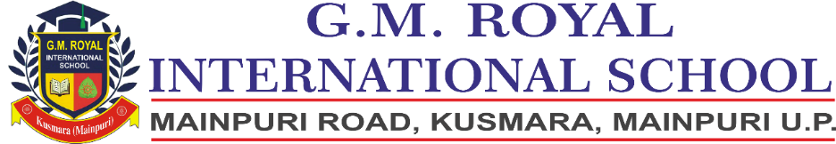

**Ref: GMRIS/2024-25/Cir/ Parents/003 04/05/2024**

**Circular Regarding Holiday**

Dear Parents, Jai Hind!

Kindly note that the school will remain closed on **06/05/2024 and 07/05/2024** due to **Lok Sabha Elections** and will **re-open** on **08/05/2024 as usual**.

**Gaurav Agarwal**

**Principal**